## Library Module – Shared Library

1. Create 3 files as below.
2. libapplication.c – will contain main() and will invoke functions in cal_utility.c

Ans)

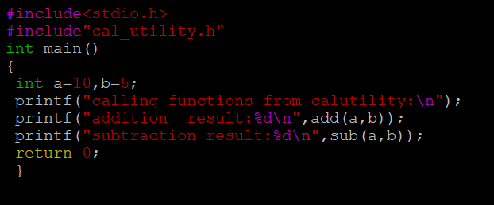

1. cal_utility.c – will contain atleast 2 or more functions [ You may add definitions of the functions in this file ]

Ans)

c)cal_utility.h – will contain the extern declarations/prototypes of the functions in cal_utility.c

Ans)

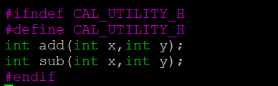

2)Refer the steps for shared library and create a shared library comprising of cal_utility.c,.h files

Ans) To create a shared library, we need to first compile cal_utility.c file using -fPIC option to create a.o file. This .o file will form the shared library, to do that use gcc command with option -shared to create shared library as below. [Ensure that library name is prefixed with “lib” and extension as “.so”]

gcc -FPIC -c cal_utility.c

gcc -shared -o libcal_utility.so cal_utility.o

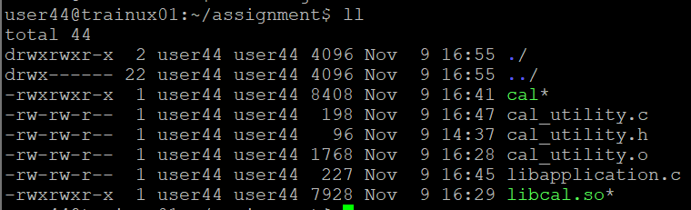

3)Create an executable using shared library.

Ans) gcc libapplication -L ./ -lcal -o cal

4)Execute the application created step 3.

Ans) ./cal

